Execute all scripts from the [devops-cloud-documents-13](https://techiehorizon.slack.com/archives/C08TMFAKPNU) channe

1) Sanity test

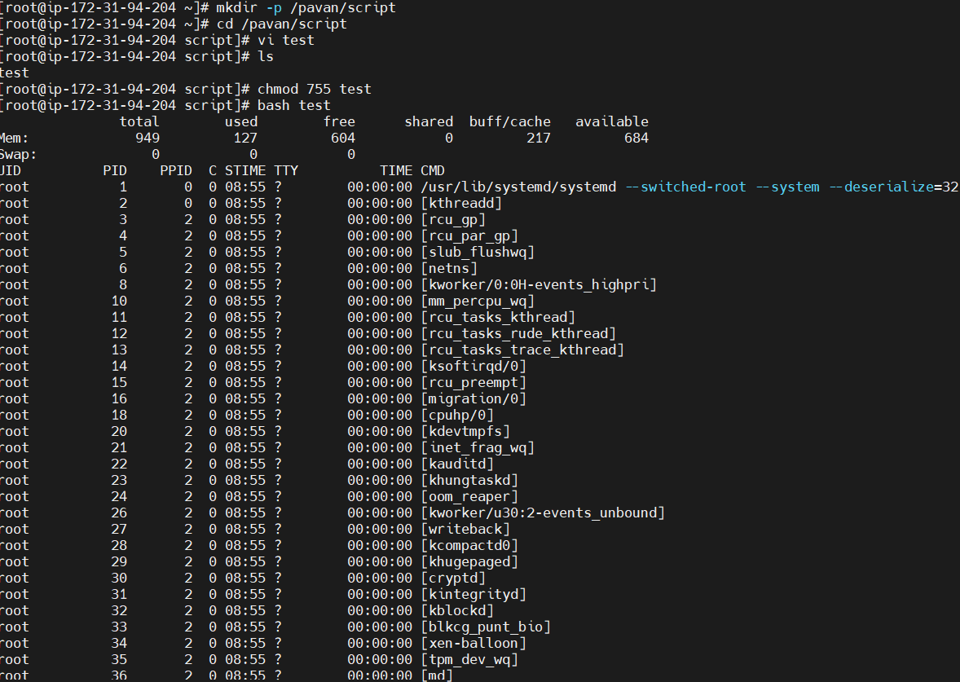

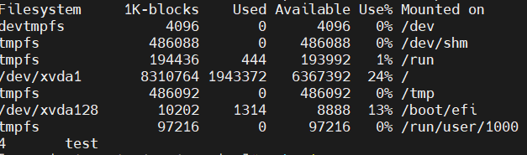b

1. Which shell you are using

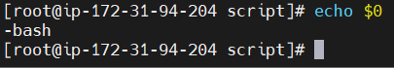

1. How many shells are available

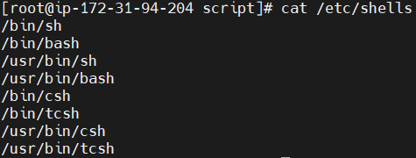

1. Which user is associated with which shell

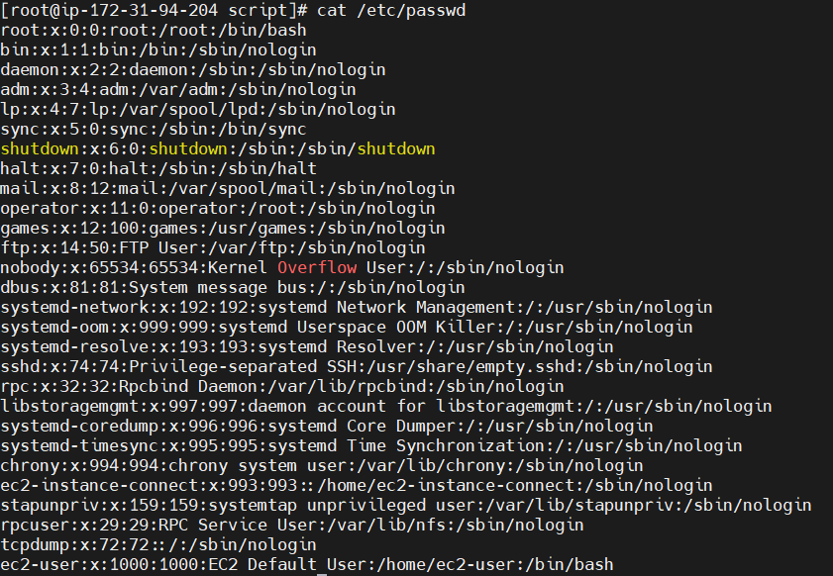

1. How to switch to different shell

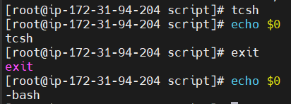

1. Basic admin task

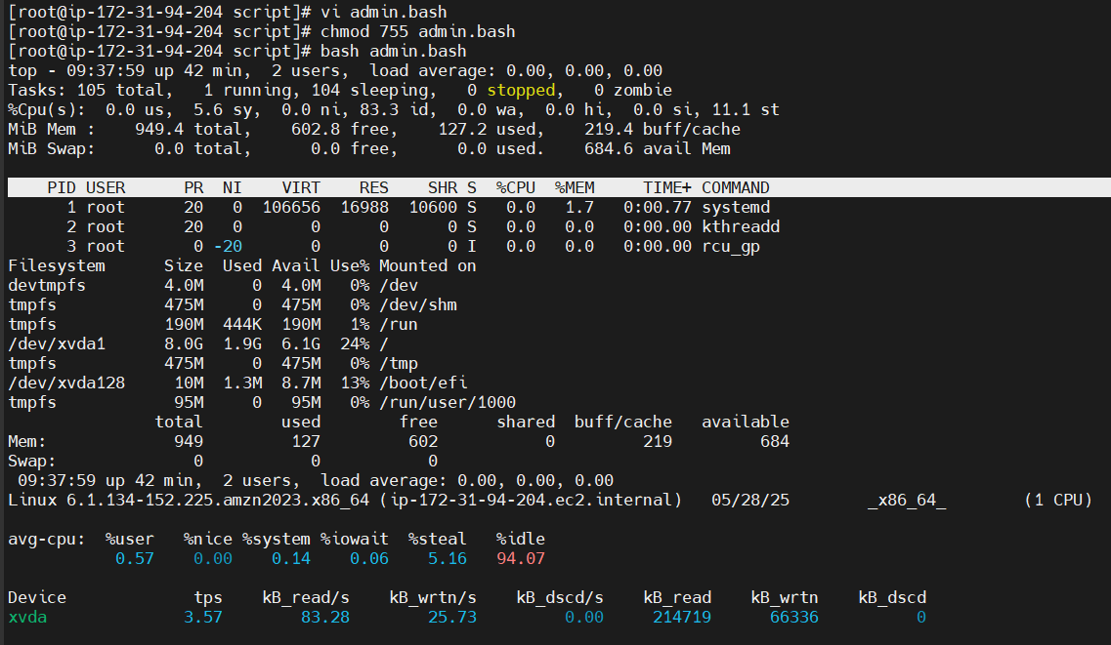

1. Defining Variables

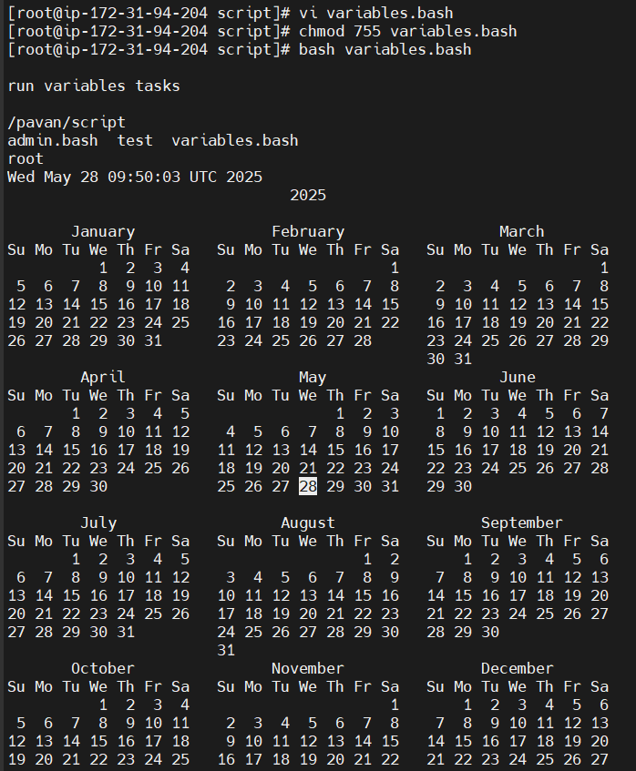

1. Input/output scripts

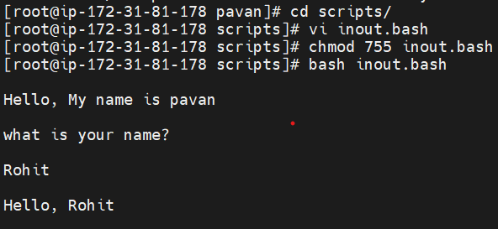

1. Input/output scripts 2

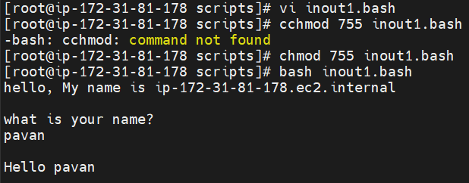

write a script to print Hello wrold ?

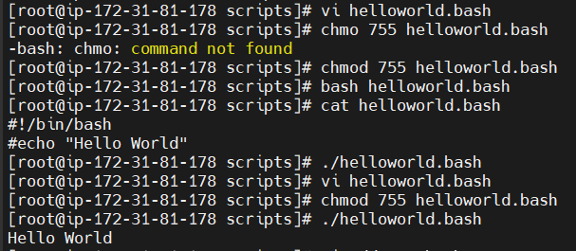

write a script to add 2 number

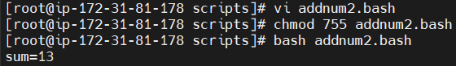

write a script to create a directory and check weather its created ?



write a script to create multiple directory ?

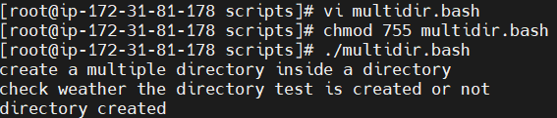

**write a script using if statement**

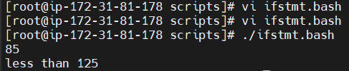

**write a bash script to create a directory but need to check whether its already**

**there or not if directory not exists then directory has to created ?**

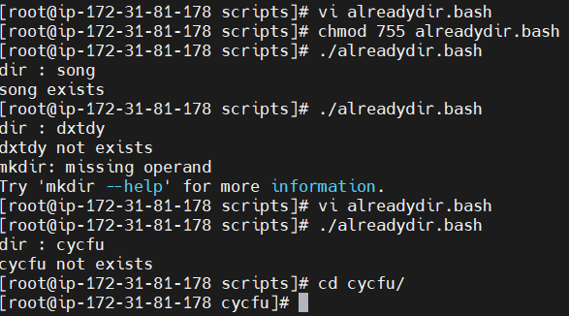

**Case multiple choices**

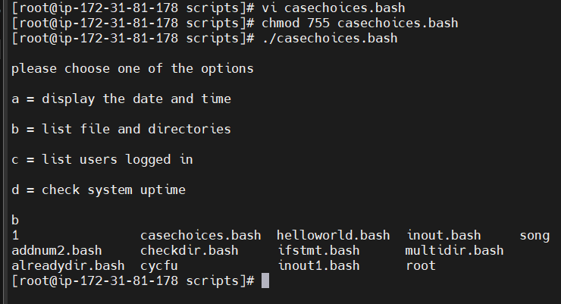

Script to run for a number of times

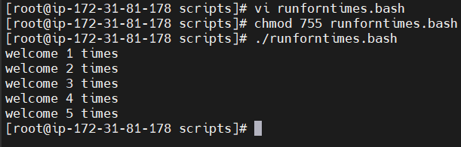

Script to run for a number of seconds

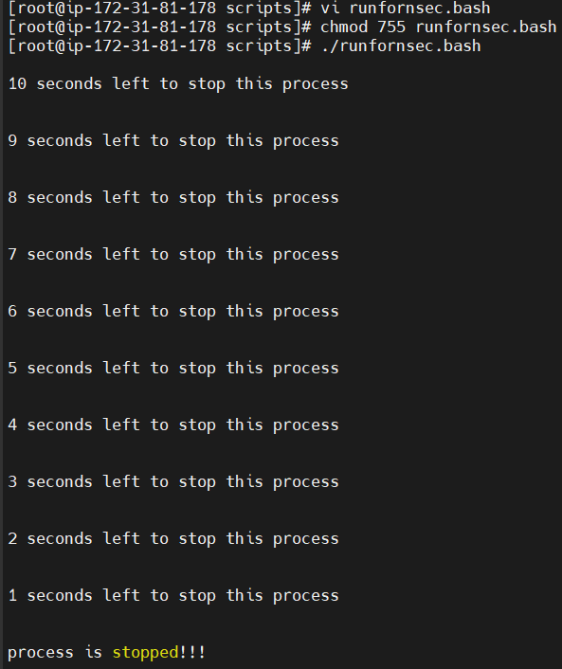

Simple for loop output

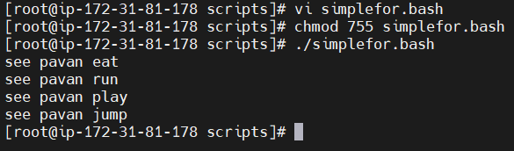

for loop to create 5 files named 1-5

delete 5 files

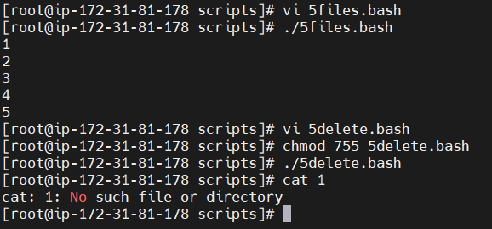

Specify days in for loop

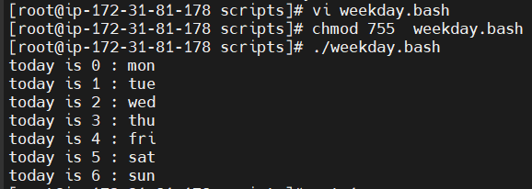

List all the users in /etc/passwd

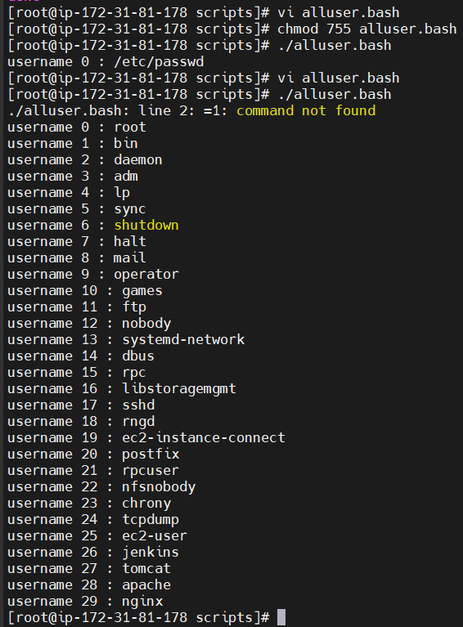

Check the variable

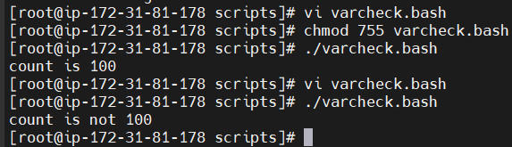

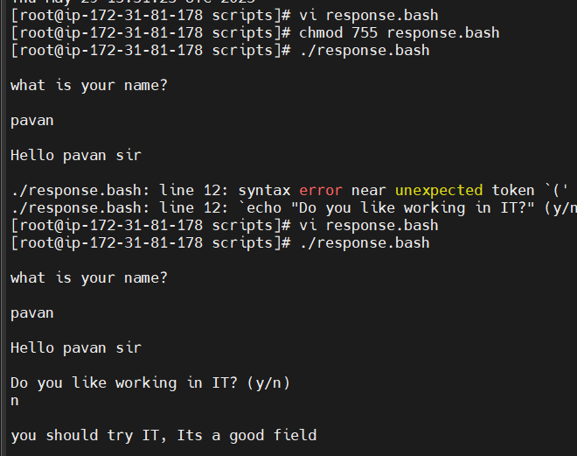

1. Create a bash script to check if a directory is available or not.

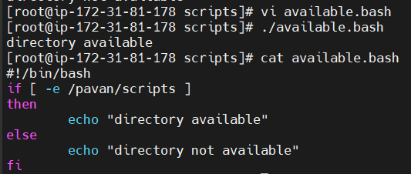

1. Create a bash script to create multiple files.

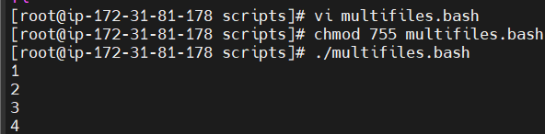

1. Create a bash script to take a backup of a directory.

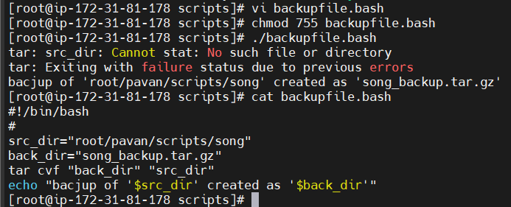

1. Create a bash script to install Nginx on an EC2 server.

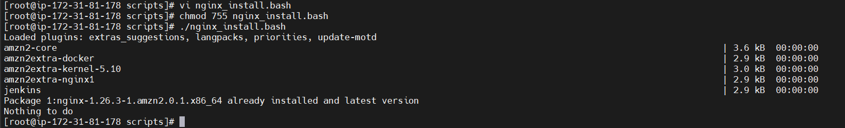

1. Create a bash script to install Apache Tomcat on an EC2 server.

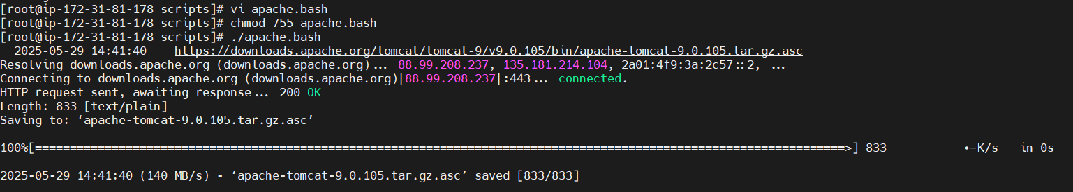

1. Create a bash script to check if the Nginx service is running, and

start it if not.

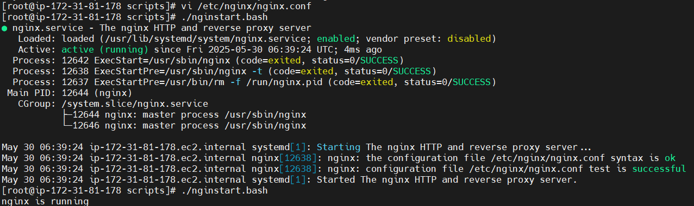

Create a bash script for a calculator.

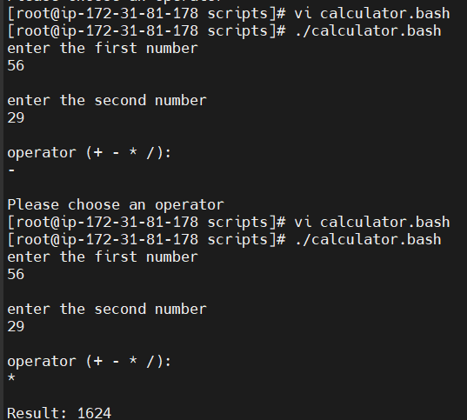

1. Create a bash script to check if a directory exists, and create it if

not.

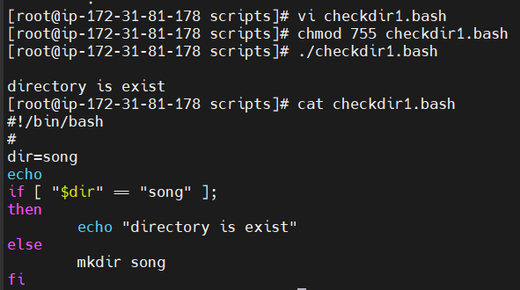

Create a bash script to delete the last 3 lines of a file.

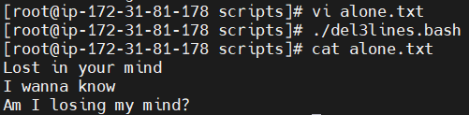

**1) April 5th Midnight**

**2) 5 th of Every November,Jan,June if it is a Thursday. 3) At 05 and 27th minutes of 9,10,11 hours everyday. 4) 34 min. of 9th hour on 15th Aug.**

**5) Every midnight**

**6) Every Weekend ( Saturday night 11.59 )**

**7) After every reboot**

